# Add a friend

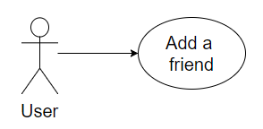

## Characteristic Information

|  |  |
| --- | --- |
| Superior business process: | Process-ID: refers to section 2.2 |
| Goal: | There is a new friend in the friend list with which you can communicate |
| Precondition: | The user needs to have a friend which he wants to add  Also you need his Tag |
| Postcondition: | You edited your friend list in form of adding friends |
| Involved User: | User: Is able to add another user from his friend list  Friend: is able to accept or decline the friend request |
| Triggering Event: | Searches friend with Tag and send a friend request or accept a friend request |

## GUI to call the use case

## GUIs for the standard use

| Step | User | Activity |
| --- | --- | --- |
| 1 | User | Start program |
| 2 | User | Press add button |
| 3 | User | Insert valid Tag |
| 4 | User | Confirm |

## Scenarios for non-standard uses (bad cases or work around cases)

## GUIs for the non-standard uses

## Workflow

## Open Points